Name | Li Yong | Gender | 男 | 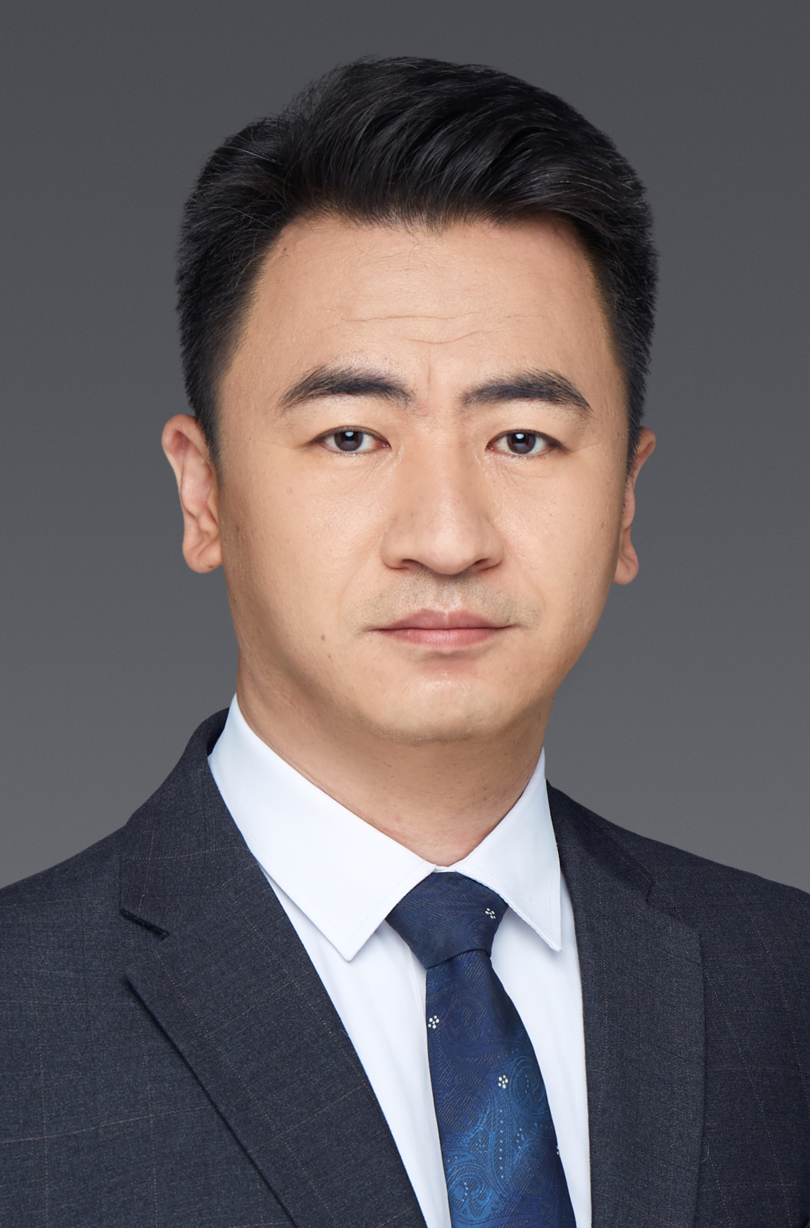
Title | Prof. | Degree | Ph.D.
Position | Assistant Director | Date of birth | 1980.9.11
Organization | Central Iron and Steel Research Institute Company Limited
Research  Area | - Strengthening and toughening mechanism of ultra-high strength steel and its engineering application  - Near Net Shape Forming

