Name | Shan Debin | Gender | Male | 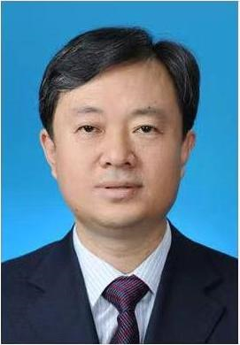
Title | Professor | Degree | Doctor
Position | Teacher | Date of birth | 1967.05.26
Organization | Harbin Institute of Technology
Research  Area | Plastic forming theory and technology, Spinning processing, Precise forging processing, Micro-forming processing

